MST -2

Assignment

Set: F

Advanced java

Submitted by: Submitted to:

Name: Utsav Mori Mr. Sachin chirgaiya

Enrol:1810DMTCYFS03240 sir

Section: I

Branch:Btech+Mtech(CYFS)

Given the current situation of Covid19,Due to lockdown a lot of families are require their daily need thing like(Vegetables, Fruits and Milk) .These daily-need things are now depend on the state government .Government need the data of such families .To achieve this a JSP/servlet based application is required to collect the data of the families. Apart front the name of the family member, family samagra id and mobile number we also need current address with ward number and zone No, and number of family member living with him. Suppose you need to build this project.

**1) Provide the databases schema (tables and relations) for the project.**

This the databases schema for daily needed thing order by local people to distributer followed by government

This entity relationship diagram was made in ms access 2013.

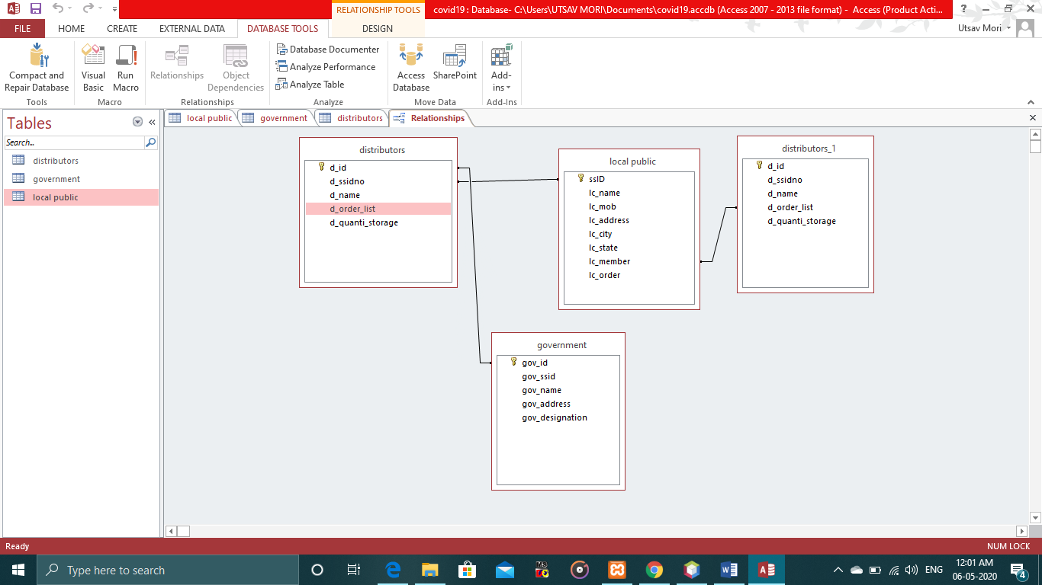And again different table made by me of user i.e. local public table in xampp server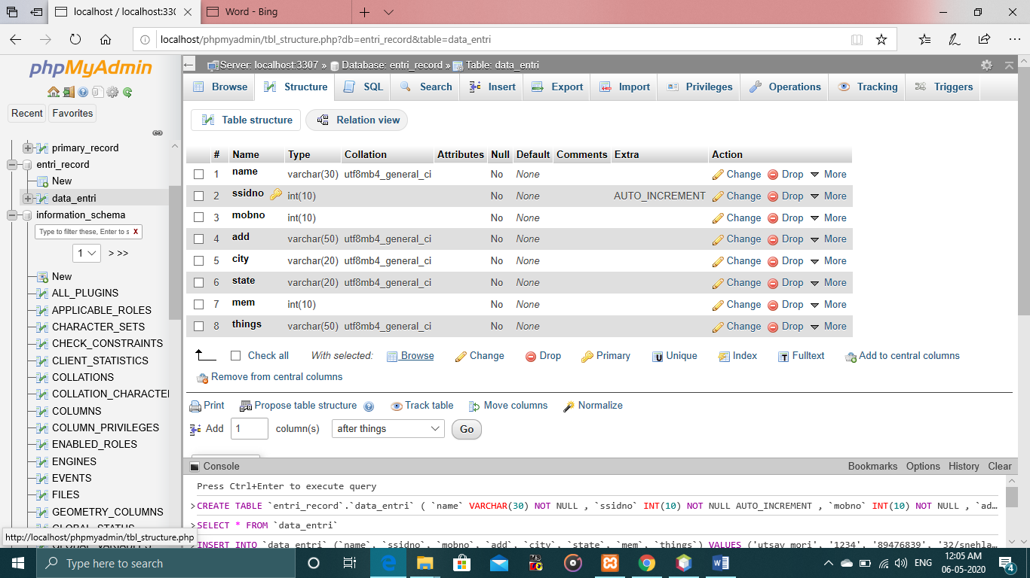

**2) Describe all the servlet classes and their functionalities that you need to build this project.**

|  |
| --- |
| **HTTP Servlet**  The HttpServlet class extends the GenericServlet class and implements Serializable interface. It provides http specific methods such as doGet, doPost, doHead, doTrace etc. |

There are many methods in HttpServlet class. They are as follows:

1. **public void service(ServletRequest req,ServletResponse res)** dispatches the request to the protected service method by converting the request and response object into http type.
2. **protected void service(HttpServletRequest req, HttpServletResponse res)** receives the request from the service method, and dispatches the request to the doXXX() method depending on the incoming http request type.
3. **protected void doGet(HttpServletRequest req, HttpServletResponse res)** handles the GET request. It is invoked by the web container.
4. **protected void doPost(HttpServletRequest req, HttpServletResponse res)** handles the POST request. It is invoked by the web container.
5. **protected void doHead(HttpServletRequest req, HttpServletResponse res)** handles the HEAD request. It is invoked by the web container.
6. **protected void doOptions(HttpServletRequest req, HttpServletResponse res)** handles the OPTIONS request. It is invoked by the web container.
7. **protected void doPut(HttpServletRequest req, HttpServletResponse res)** handles the PUT request. It is invoked by the web container.
8. **protected void doTrace(HttpServletRequest req, HttpServletResponse res)** handles the TRACE request. It is invoked by the web container.
9. **protected void doDelete(HttpServletRequest req, HttpServletResponse res)** handles the DELETE request. It is invoked by the web container.
10. **protected long getLastModified(HttpServletRequest req)** returns the time when HttpServletRequest was last modified since midnight January 1, 1970 GMT.

**3) Describe all the non-servlet java classes and their functionalties that you will use in servlet classes**

The non-servlet java classes which I used in my project is register class in that which is extend by Httpservlet class

After process request of extended class i.e. HttpServlet is used in Register class followed by two parameter that is HttpServletRequest request, HttpServletResponse response .

Then try block is start in which basic html statement get print by out. println . out.println is a Java statement that prints the argument passed.

Then there is declaration of variables of data type strings and through request.getparameter() method we store it in the above variables.

Then jdbc connection get establish to connect the xampp MySQL to servlet.

Their following register, connection , statement and execute interface objects are used .

1) **Register the driver class**

|  |
| --- |
| The **forName()** method of Class class is used to register the driver class. This method  is used to dynamically load the driver class. |

**2) Create the connection object**

|  |
| --- |
| The getConnection() method of DriverManager class is used to establish connection with  the database. |

**3) Create the statement object**

The createStatement() method of Connection interface is used to create statement. The object of statement is responsible to execute queries with the database.

**4) Execute the query**

The executeQuery() method of Statement interface is used to execute queries to the database. This method returns the object of ResultSet that can be used to get all the records of a table.

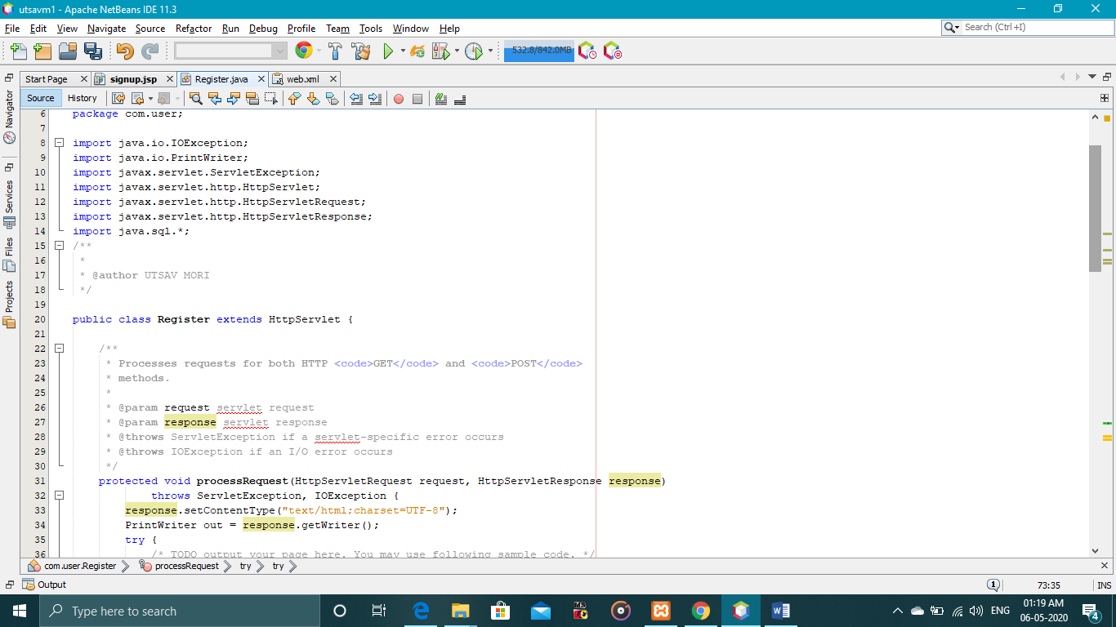

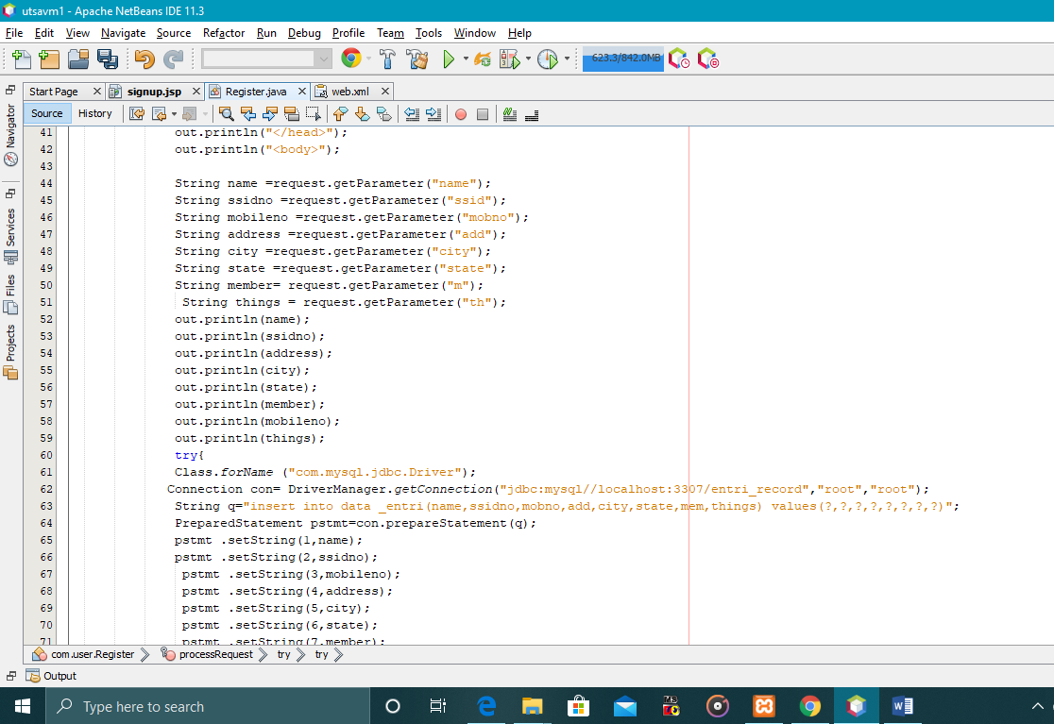

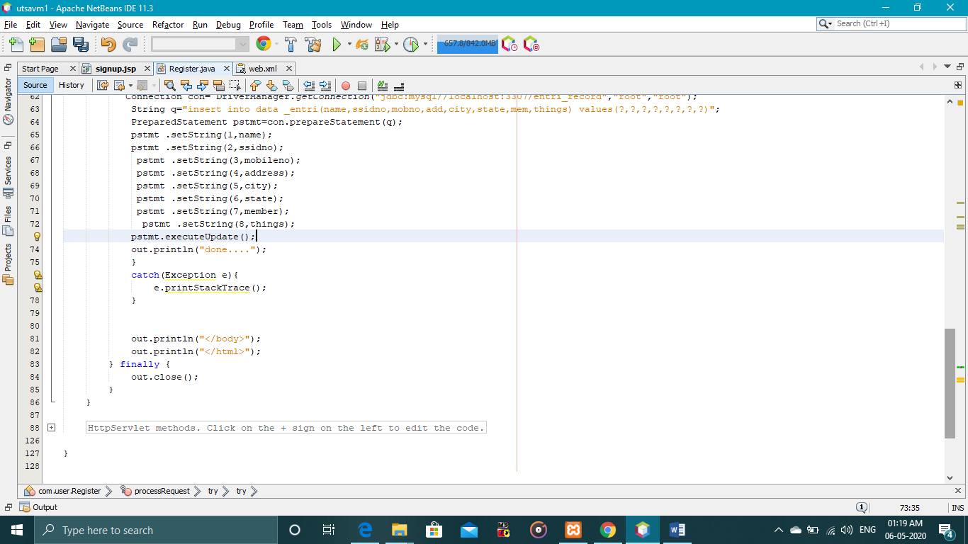

**4. Describe all the major challenges that you may face to build this project.**

The major challenge which I face while making the projects are:

1. The first challenge is to make path from xampp appache tomcat to net beans ide later it get resolved by going this process i.e.

NetBeans🡪services🡪server🡪add new🡪add name 🡪 set path of tomcat

(c: /user/Utsav Mori/xampp/tomcat)🡪add username🡪password for authentication.

2. Next challenge which I face is the error 404, when I suppose to run the program first of all then the data which I suppose to write in the front end get reach to servlet file or not but I got error 404, with statement line

**The origin server did not find a current representation for the target resource or is not willing to disclose that one exists**.

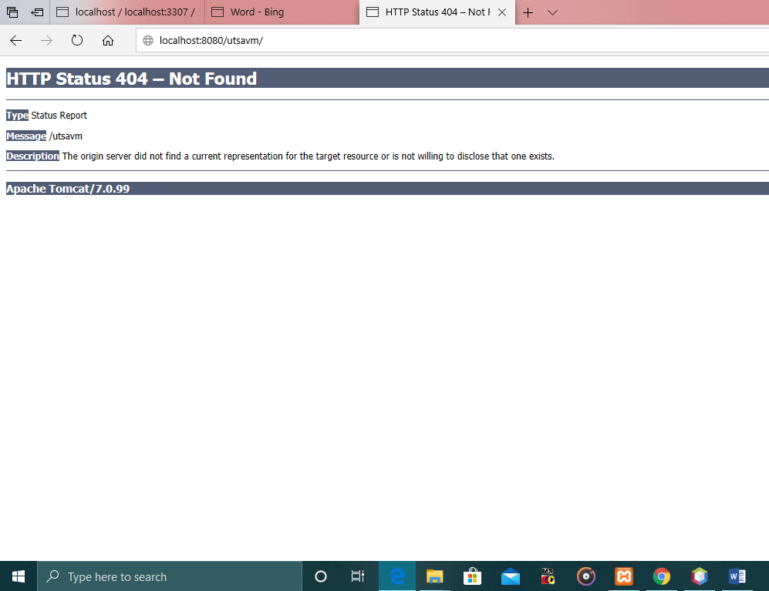

This get resolve by going to web.xml🡪check the name i.e./name is same as that of that servlet file name .But this issues take my most of the time.

**5. Build the application and submit the java source file and database . sql file**

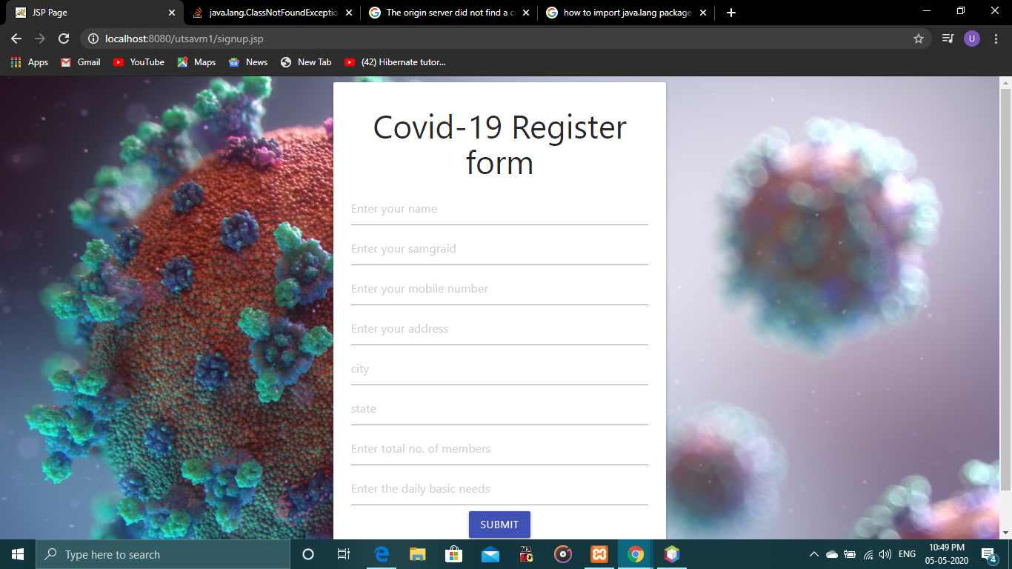

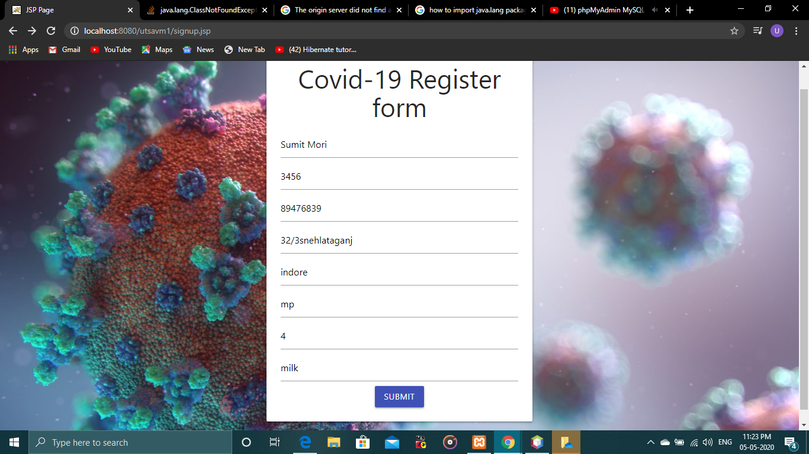

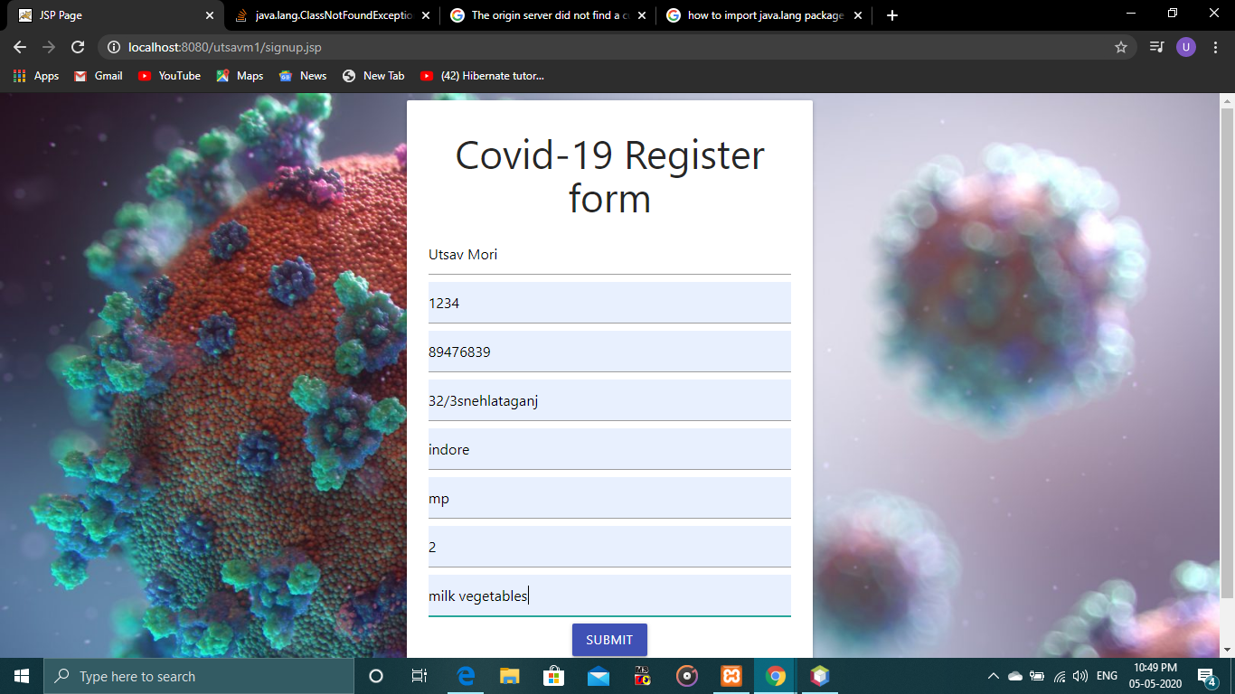

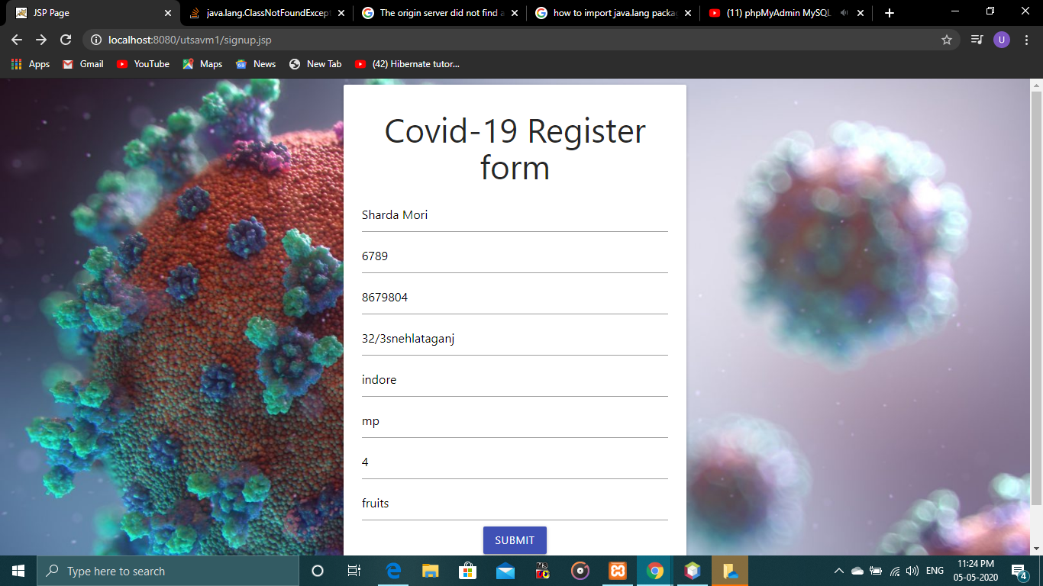

**Data base name: entri_record**

**Table name: data_entri**

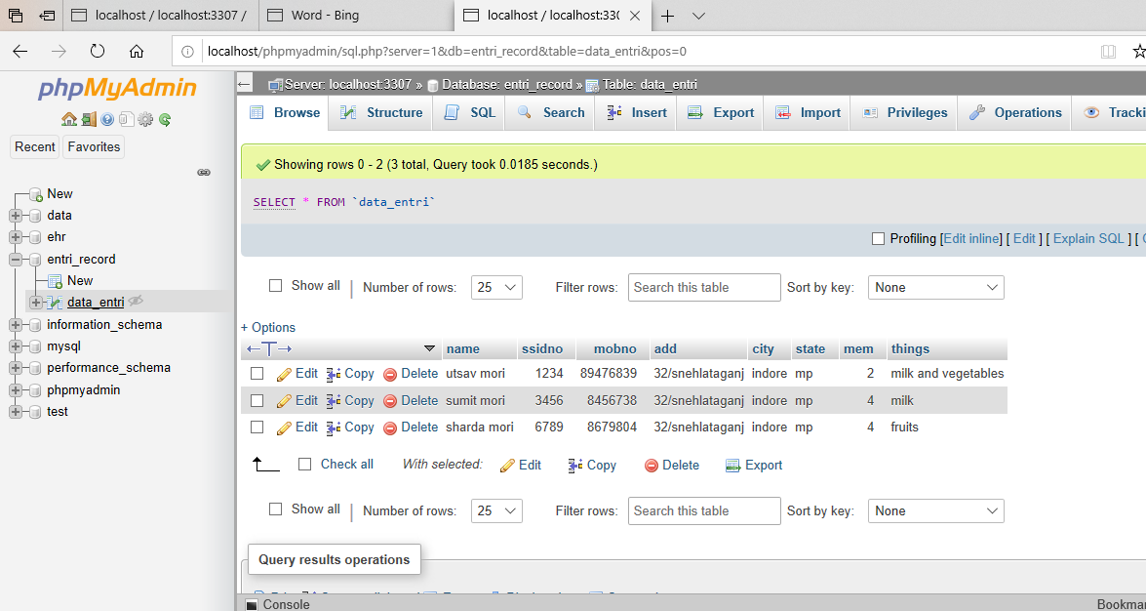

Data stored in the above xampp MySQL server

**Files of project** [utsav covid19project - Copy.zip](utsav%20covid19project%20-%20Copy.zip)



**Above is the er diagram file and whole project zip file**

**Below is the database file**

